**Ideation Phase**

**Define the Problem Statements**

|  |  |
| --- | --- |
| Date | 20 May 2023 |
| Team ID | NM2023TMID13373 |
| Project Name | IoT based smart city waste management system with connected trash cans |
| Maximum Marks | 2 Marks |

**Customer Problem Statement Template:**

Create a problem statement to understand your customer's point of view. The Customer Problem Statement template helps you focus on what matters to create experiences people will love.

A well-articulated customer problem statement allows you and your team to find the ideal solution for the challenges your customers face. Throughout the process, you’ll also be able to empathize with your customers, which helps you better understand how they perceive your product or service.

**Example:**

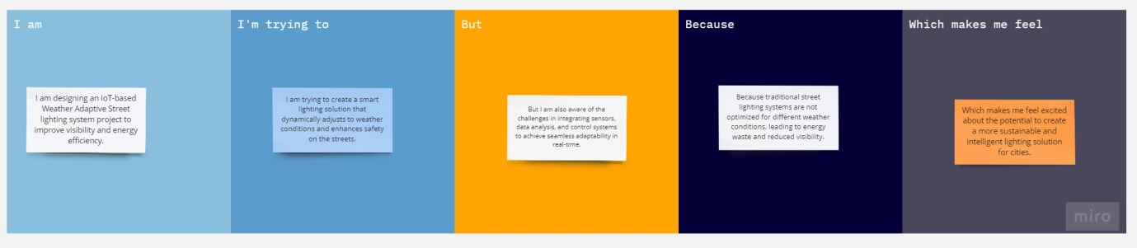

|  |  |  |  |  |  |
| --- | --- | --- | --- | --- | --- |
| **Problem Statement (PS)** | **I am (Customer)** | **I’m trying to** | **But** | **Because** | **Which makes me feel** |
| PS-1 | A city planner | Improve street lighting system | But the current system lacks adaptability and energy efficiency | Because it leads to wasted energy and compromised safety | Which makes me feel the need for a more intelligent and sustainable solution. |
| PS-2 | A pedestrian | Ensure safe navigation during different weather conditions | But existing street lights are not optimized for weather variations | Because it hampers visibility and increases the risk of accidents | Which makes me feel vulnerable and concerned for my safety. |